Music Playlist Organizer

Submitted By:

- Team Members – Anindita Saha, Jessica John Osta  
- Roll Number – 2460328, 2460376

Course: UI/UX Design Fundamentals

Instructor Name: Nagaveena

Institution: Christ (Deemed to be University)

Date of Submission: 26/09/2025

## Abstract

This project focuses on designing and developing an interactive Music Playlist Organizer using HTML, CSS, JavaScript, Bootstrap, and jQuery. The platform enables users to organize, browse, and manage playlists efficiently by offering features such as playlist listings, search and filter functionality, and detailed track information. The key goal is to create a responsive and user-friendly web application that enhances the music browsing experience across devices. The outcome is a fully functional prototype that demonstrates playlist management, interactive filtering, and a clean UI layout, useful for music enthusiasts and developers exploring front-end development.

## Objectives

* Design a visually appealing and user-friendly interface for music playlist management.
* Implement playlist listing with cover images, titles, and descriptions.
* Develop search and filter features to categorize playlists by genre, mood, artist, or duration.
* Create a Playlist Details Page showing complete tracklists with play, edit, and remove options.
* Ensure responsiveness and accessibility using Bootstrap’s grid system and utilities.
* Apply JavaScript and jQuery for interactivity and dynamic content updates.

## Scope of the Project

* Focused on front-end development with interactive features.
* Covers playlist browsing, filtering, and track listing.
* No backend or database integration in the current scope.
* Supports multiple devices (desktop, tablet, mobile) via responsive design.
* Uses only open-source tools and frameworks (HTML, CSS, JS, Bootstrap, jQuery).

## Tools & Technologies Used

|  |  |
| --- | --- |
| Tool/Technology | Purpose |
| HTML5 | Markup and content structure |
| CSS3 | Styling and layout management |
| Bootstrap | Responsive grid and components |
| JavaScript | Dynamic content and interactivity |
| jQuery | Simplified DOM manipulation and event handling |
| VS Code | Code editor |
| Chrome DevTools | Testing and debugging |

## HTML Structure Overview

* Used semantic tags: <header>, <nav>, <main>, <section>, <footer>
* Structured sections: Playlist Listing, Search/Filter, Playlist Details
* Playlist displayed using <div> cards with Bootstrap classes
* Navigation menu with search bar and filter options

## CSS Styling Strategy

* Used external CSS file (style.css) along with Bootstrap classes
* Organized styling with comments for sections (Navbar, Cards, Details, Responsive tweaks)
* Bootstrap Grid System for responsiveness
* Custom CSS Variables for theme colors
* Hover effects for playlist cards
* Transitions for smooth animations
* Mobile-first design with media queries

## Key Features

|  |  |
| --- | --- |
| Feature | Description |
| Responsive Design | Works seamlessly on desktop, tablet, and mobile |
| Playlist Listing | Displays playlists with cover images, titles, and descriptions |
| Search & Filter | Allows filtering by genre, mood, artist, or duration |
| Playlist Details Page | Shows full tracklist with play, edit, and remove options |
| Interactivity with jQuery | Dynamic updates for filters and playlist actions |

## Challenges Faced & Solutions

|  |  |
| --- | --- |
| Challenge | Solution |
| Managing responsiveness across devices | Used Bootstrap grid and media queries |
| Filtering playlists dynamically | Implemented JavaScript functions with jQuery for real-time filtering |
| Handling playlist layout alignment | Used Bootstrap flexbox utilities |
| Playlist card hover effect issues | Added custom CSS transitions for smoother interactions |

## Outcome

Successfully built a functional and responsive Music Playlist Organizer. Integrated search, filter, and playlist detail features using JavaScript and jQuery. Ensured a visually engaging UI with Bootstrap components and CSS styling. Gained practical understanding of interactive UI development and responsive layouts.

## Future Enhancements

* Add backend integration with a database for real playlist storage.
* Implement audio player functionality with play/pause/skip features.
* Add user authentication for personalized playlists.
* Integrate theme customization (light/dark mode).
* Include drag-and-drop playlist organization.

## Sample Code

Playlist Card Example (HTML):

Filter Function (JavaScript + jQuery):

<!DOCTYPE html>

<html lang="en">

<head>

    <meta charset="UTF-8">

    <meta name="viewport" content="width=device-width, initial-scale=1.0">

    <title>Tune Deck</title>

    <link rel="stylesheet" href="src/styles/global.css">

    <link rel="stylesheet" href="src/styles/fonts.css">

</head>

<body>

    <div id="root"></div>

    <script src="src/scripts/main.js"></script>

</body>

</html>

## Screenshots of Final Output

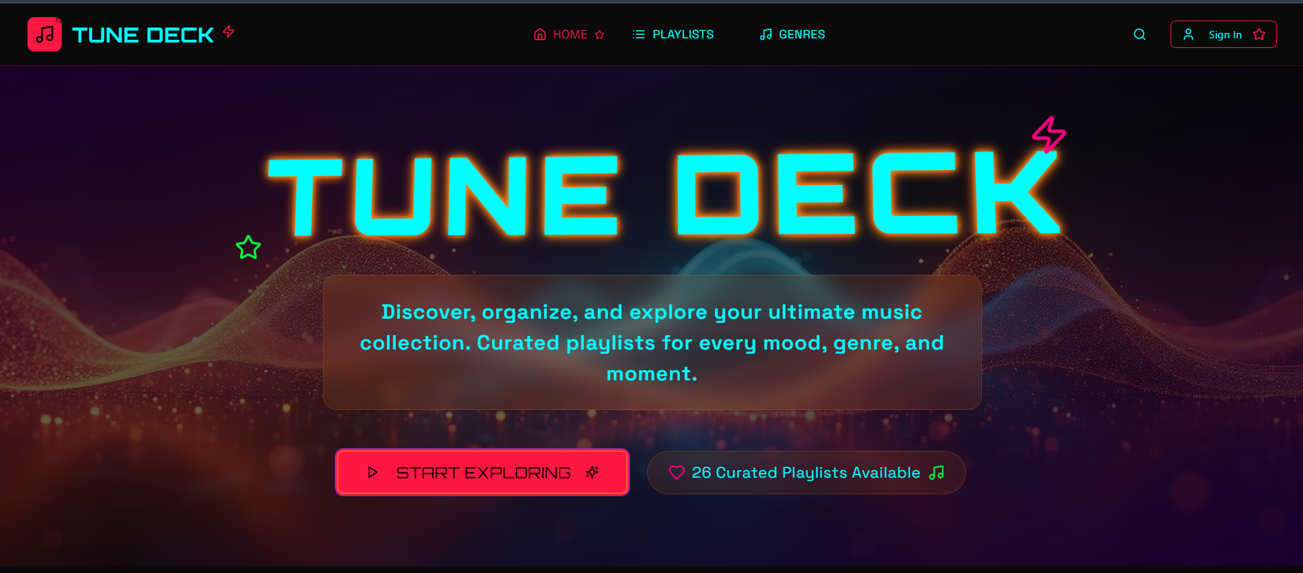

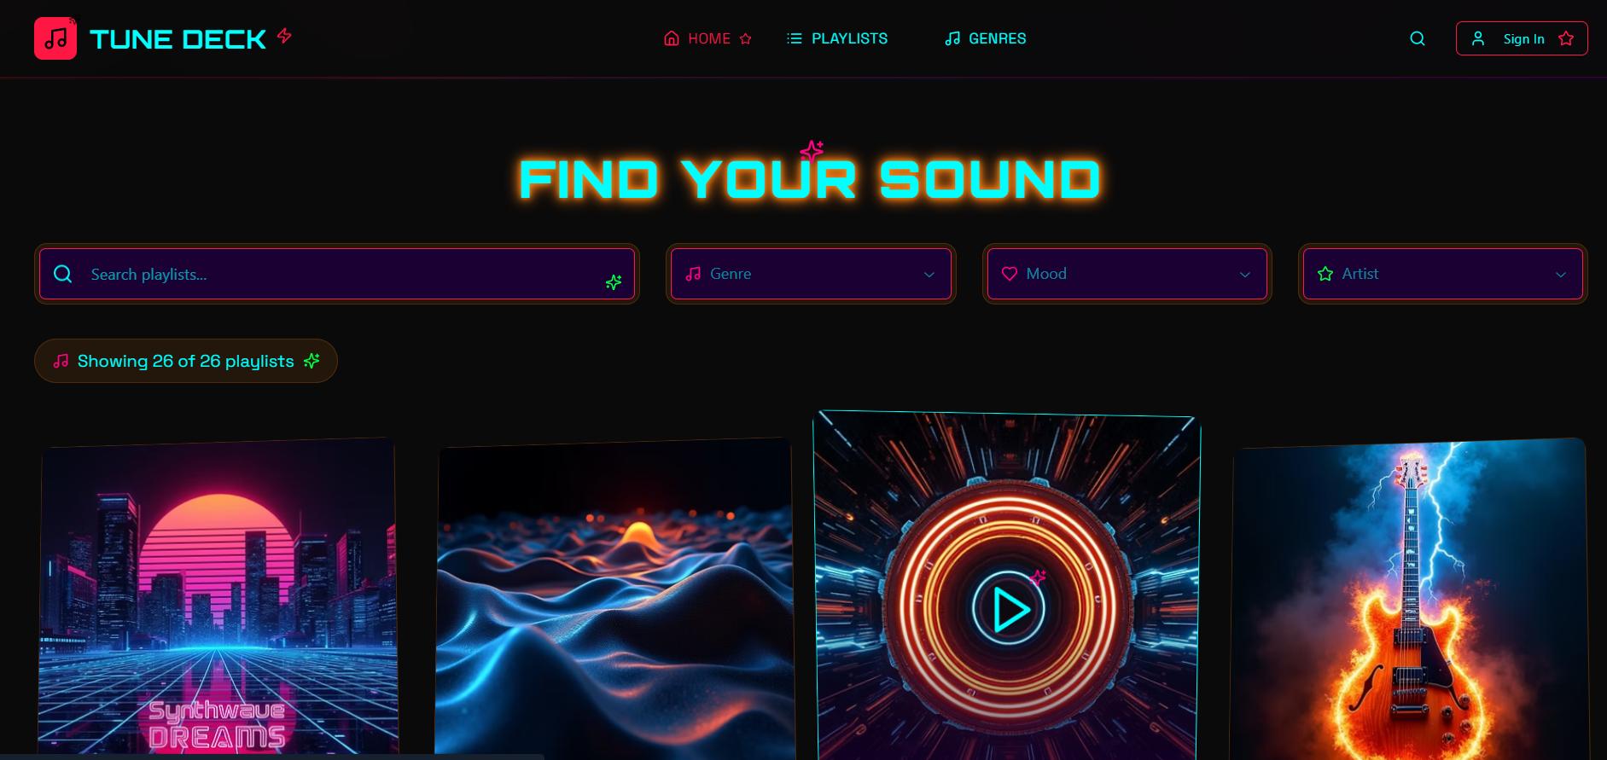

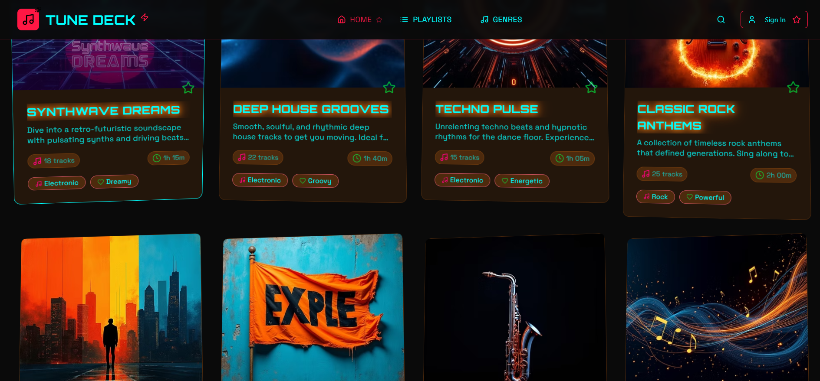

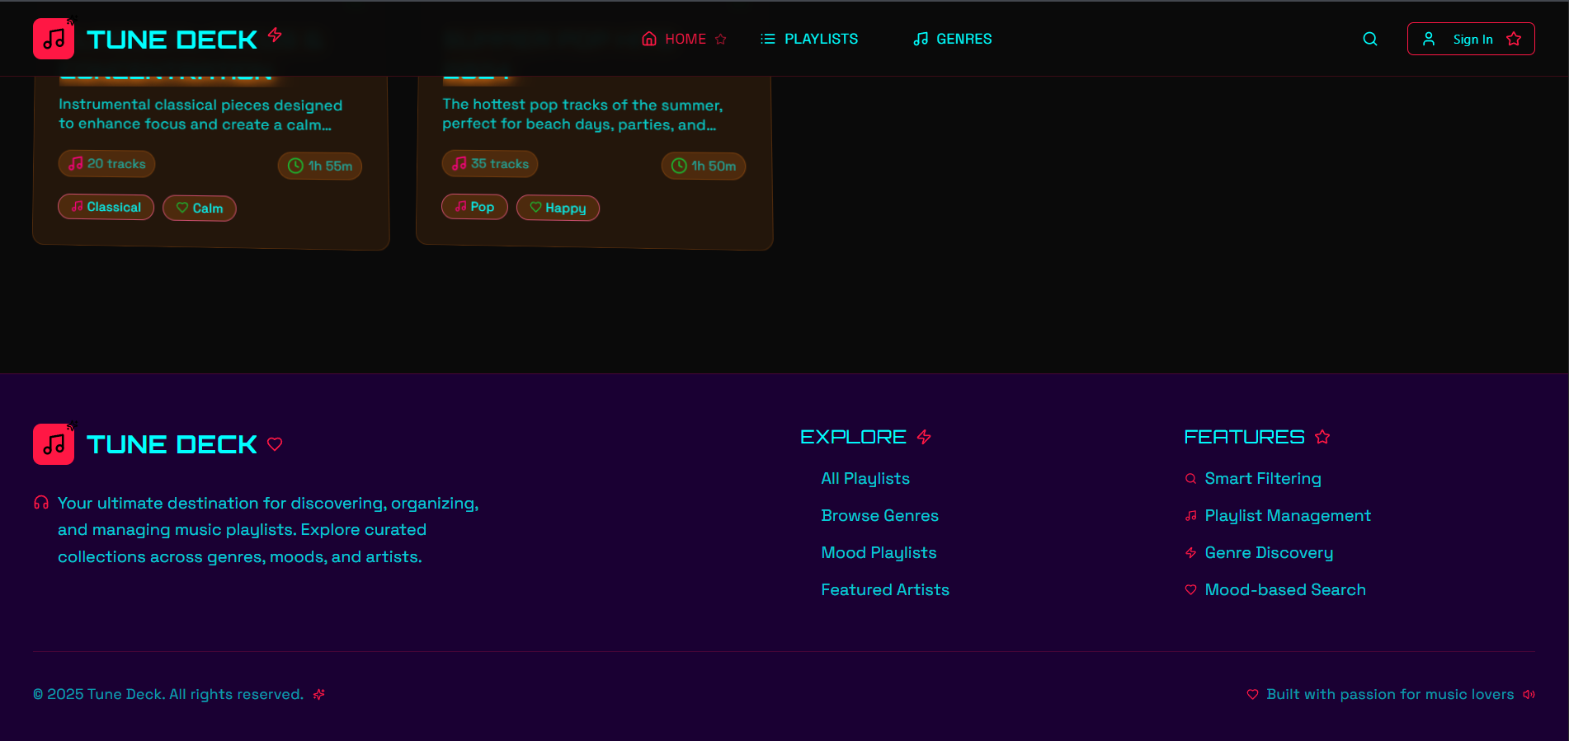

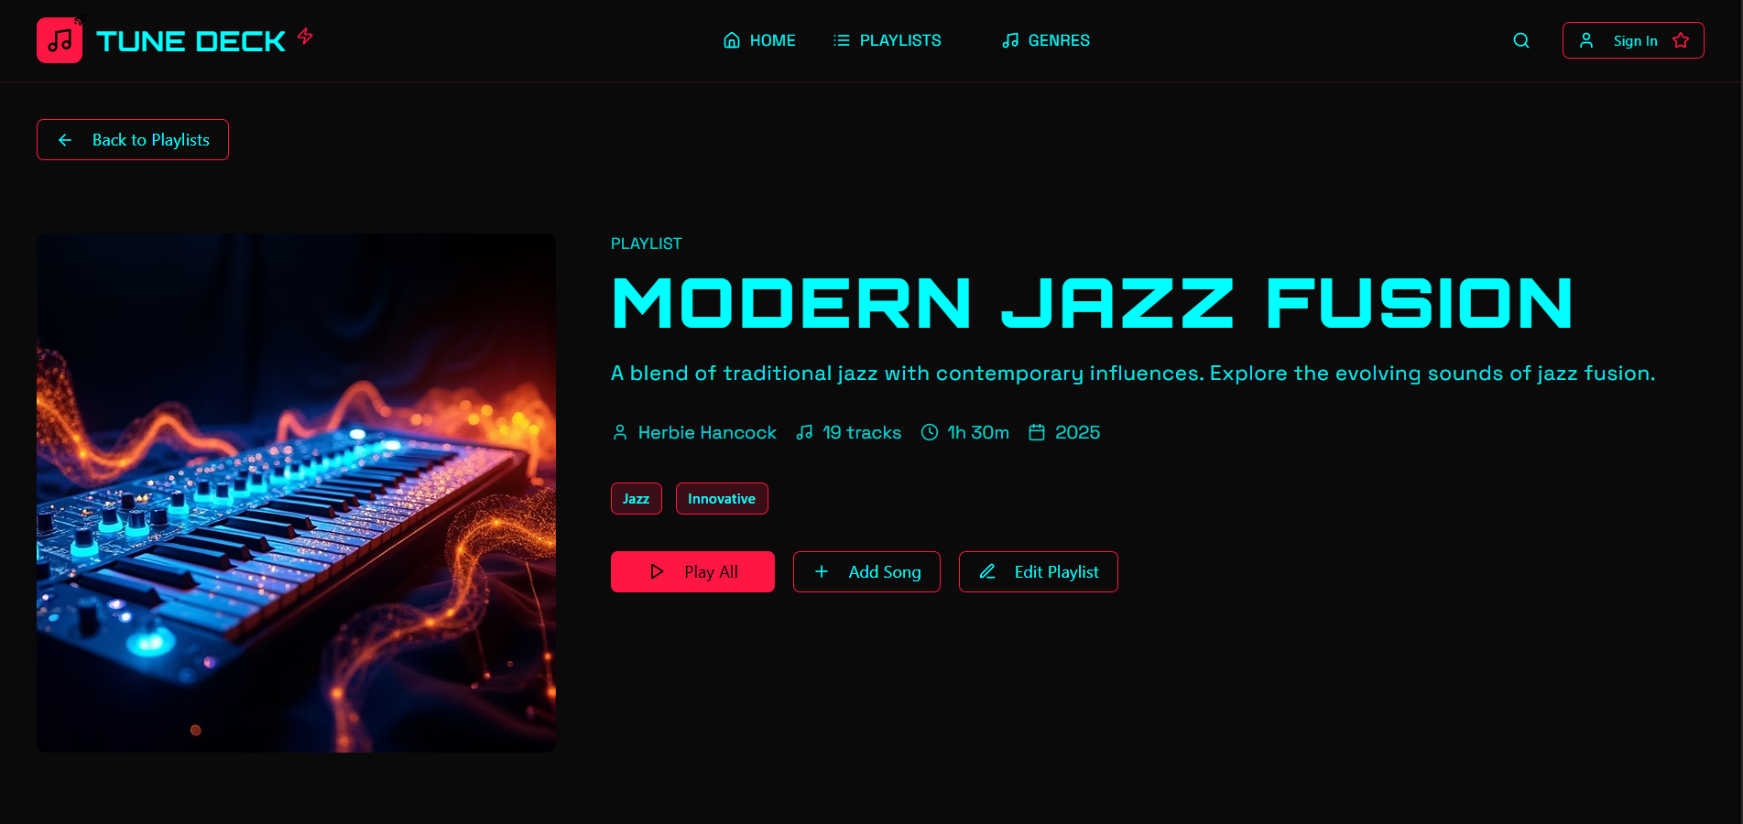

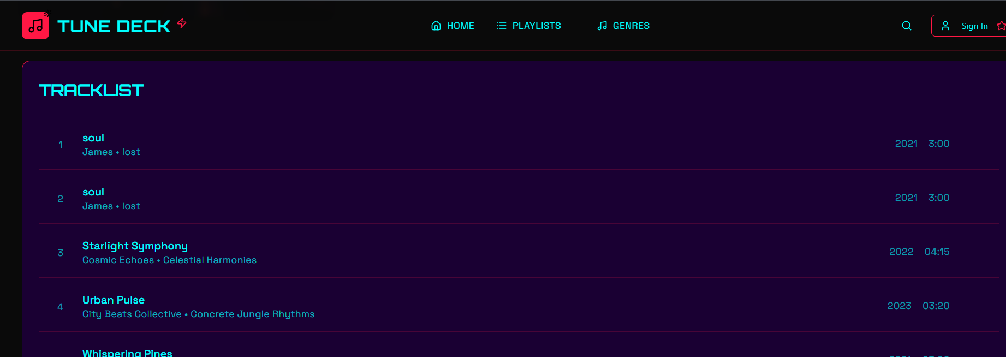

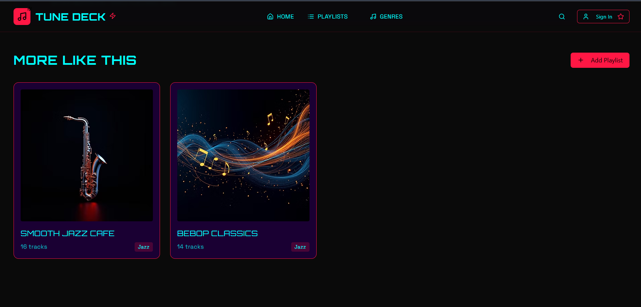

## Conclusion

The Music Playlist Organizer project demonstrates how HTML, CSS, JavaScript, Bootstrap, and jQuery can be combined to build an interactive, responsive, and user-friendly music management interface. Through this project, I enhanced my skills in UI/UX design, responsive layouts, interactivity with JavaScript, and Bootstrap integration. The hands-on approach helped me understand how to design real-world applications focusing on usability and functionality.

## References

• L&T LMS: https://learn.lntedutech.com/Landing/MyCourse

• Bootstrap Documentation: https://getbootstrap.com

• jQuery Documentation: https://api.jquery.com